**EXP NO: 01**

**STEP 1:**

Go to zoho.com and sign in or sign up.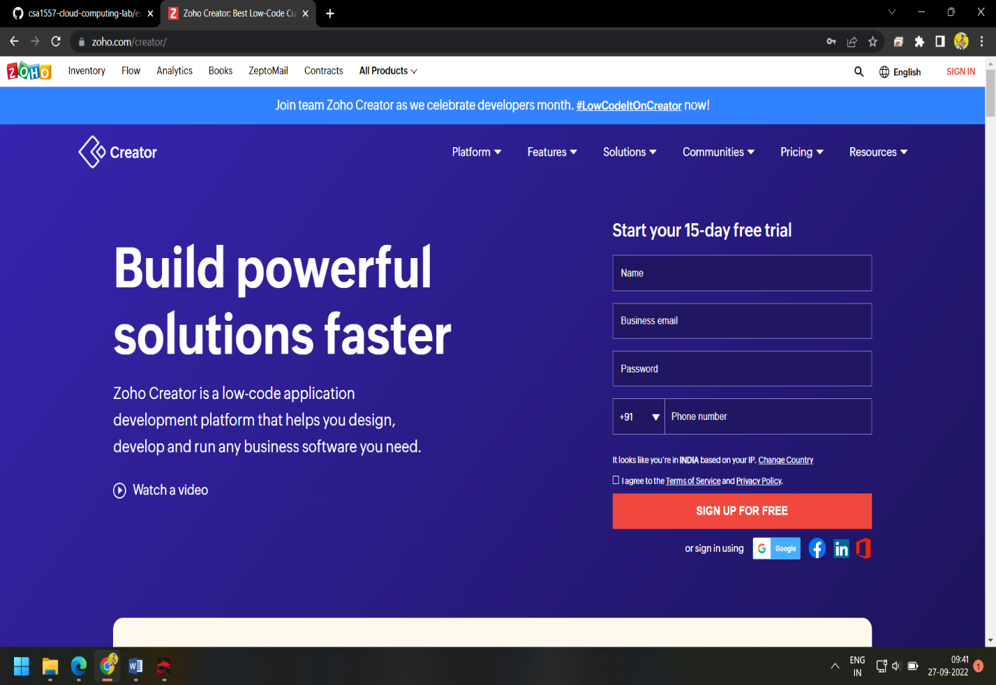

**Step 2:**Go to creator section

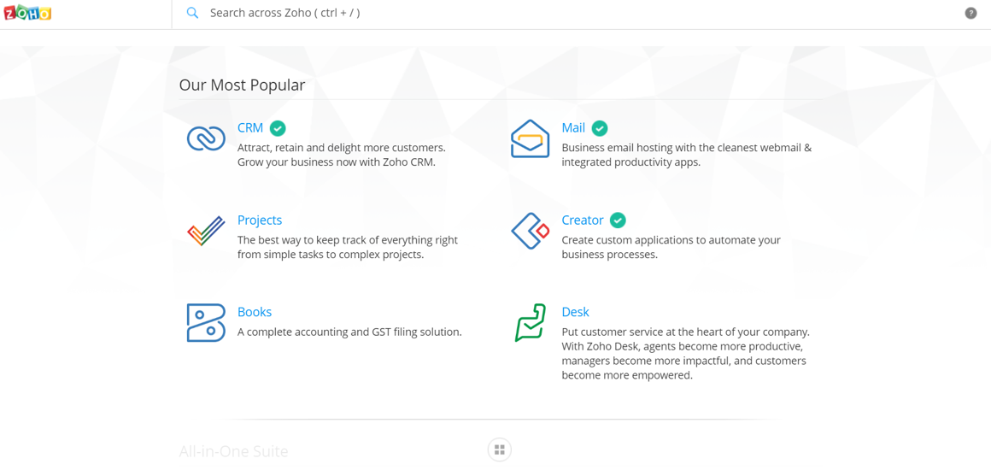

**Step-3:** Click on create new application and name application

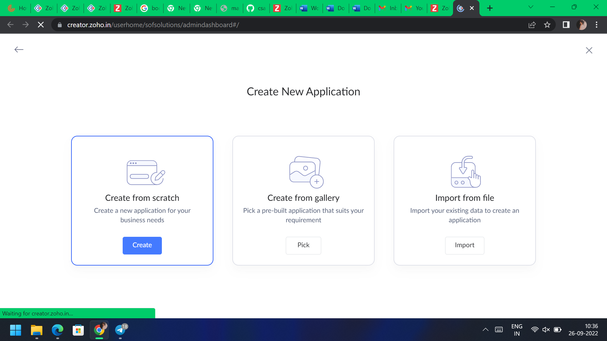

**Step-4:** Add new forms and templets as per the application.

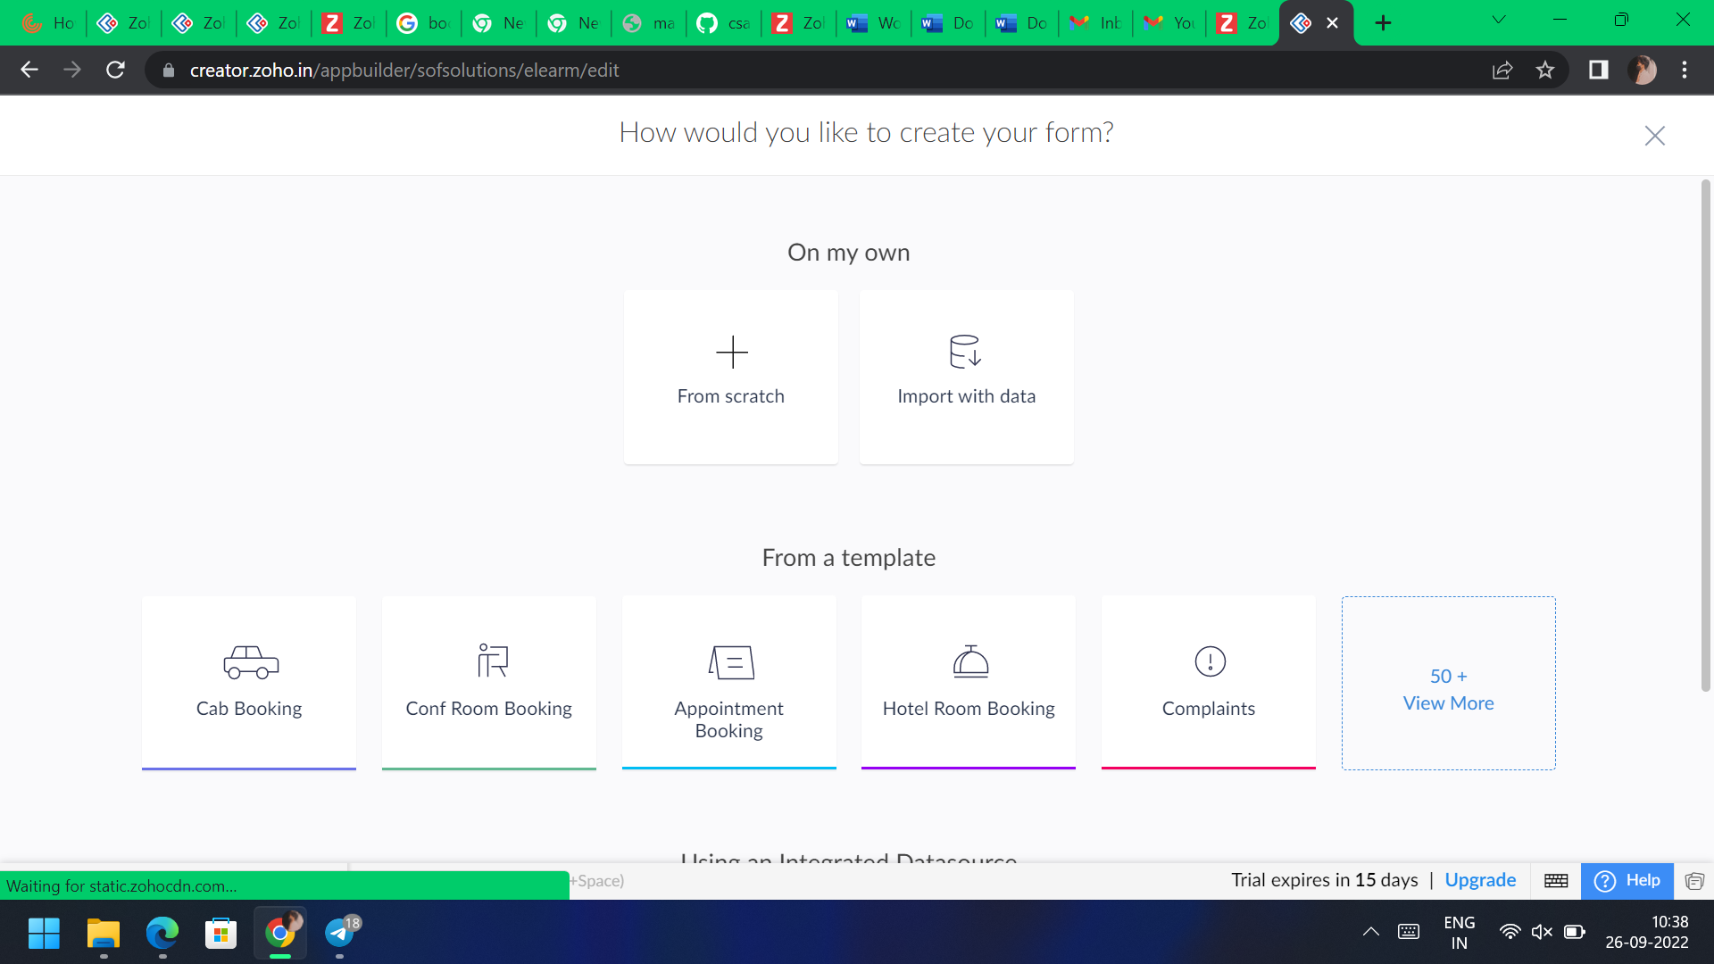

**Step-5:** Click on access application and check it.

**Outputs:**

